Strain gauge pressure sensor

**I – Definition**

A strain gauge (also spelled strain gage) is a device used to measure strain on an object. Invented by Edward E. Simmons and Arthur C. Ruge in 1938, the most common type of strain gauge consists of an insulating flexible backing which supports a metallic foil pattern. The gauge is attached to the object by a suitable adhesive, such as cyanoacrylate.[1] As the object is deformed, the foil is deformed, causing its electrical resistance to change. This resistance change, usually measured using a Wheatstone bridge, is related to the strain by the quantity known as the gauge factor. (Wikipedia)

**II – Working principle**

The foil type strain gauges (Figure #1) are very common in which a resistive foil is mounted on a backing material. These are available in a variety of shapes and sizes for different applications. The resistance of the foil changes as the material to which the gauge is attached undergoes tension or compression due to change in its length and diameter.  
   
This change in resistance is proportional to the applied strain. As this change in resistance is very small in magnitude so its effect can be only sensed by a Wheatstone bridge. This is the basic strain gauge working principle.

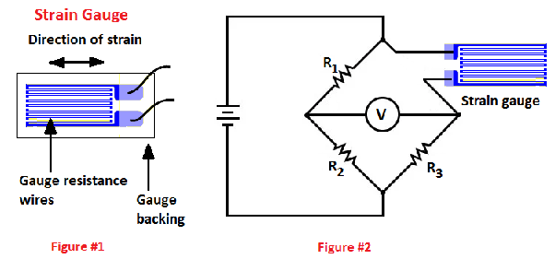

A circuit diagram is shown in Figure #2. In this circuit diagram, a strain gauge is connected into a Wheatstone bridge. This circuit is so designed that when no force is applied to the strain gauge, R1 is equal to R2 and the resistance of the strain gauge is equal to R3. In this condition the Wheatstone bridge is balanced and the voltmeter shows no deflection.

But when strain is applied to the strain gauge, the resistance of the strain gauge changes, the Wheatstone bridge becomes unbalanced, a current flows through the voltmeter. Since the net change in the resistance is proportional to the applied strain, therefore, resultant current flow through the voltmeter is proportional to the applied strain. So, the voltmeter can be calibrated in terms of strain or force.

**III – Applications**

Strain gauge technology has practically unlimited uses in the field.

**Strain Gauges in Aerospace Applications:** Strain gauges are bonded directly to structural load bearing components to measure stresses along load paths for wing deflection. Wired into Wheatstone bridge circuits, strain gauges in aerospace applications include onboard signal conditioning units, excitation power supplies, and the telemetry necessary to read in situ measurements.

**Rail Monitoring with Strain Gauges:** The use of strain gauge technology to maintain rail safety also has a long history. As just one example, strain gauges may be installed in places where a rail line is placed atop a mine. Subsidence-related ground shear requires that expansion switches be installed in the rails, so strain gauges and temperature sensors record and log data at fixed intervals. When a reading exceeds a pre-defined trigger, an alarm is dispatched via ordinary text message so personnel can respond quickly.

**Torque and Power Measurements in Rotating Equipment:** Strain gauges are used to measure the torque applied by a motor, turbine, or engine to fans, generators, wheels, or propellers. This equipment is found in power plants, ships, refineries, automobiles and industry at large.